Name of Project: Contractor Name: -
Sr. No: - Date: -
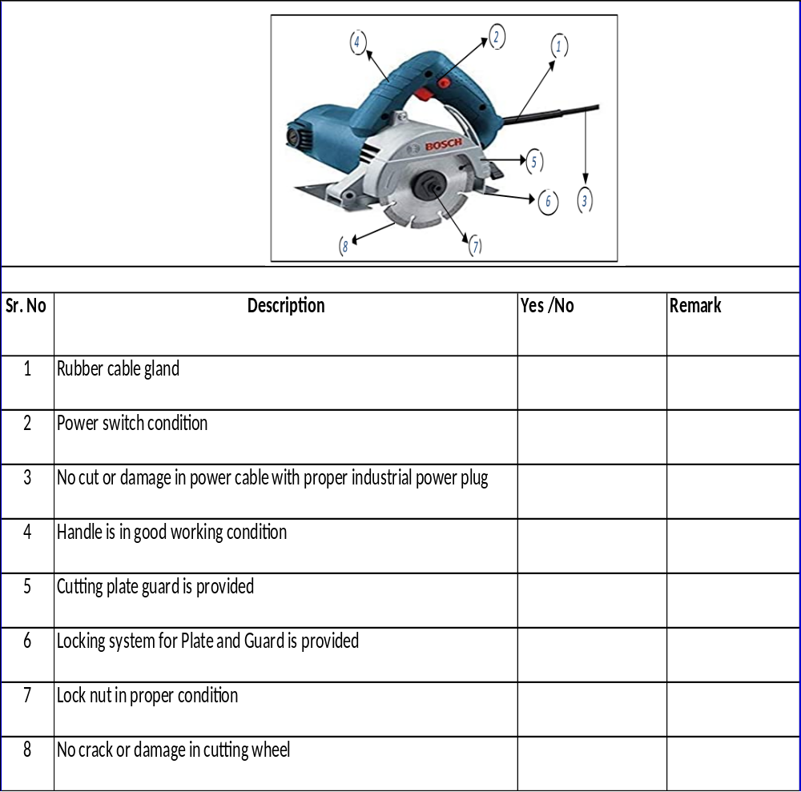

 | Name | Signature | Date
Checked by electrician
Verified By P& M in charge
Verified By EHS Officer

